# GroMore: Scenario Five and Six Report

## **Group Members:** *Vivek Singh Grewal, Amanda Triplett, Justin Warlick, Gebremeskel Tesfa*

## Scenario 5: Post agriculture model with seasonality – future projection

## Scenario 6: Is Seasonality Necessary?

The ET in the previous scenarios was on for 6 months and off for 6 months. In order to check the effects of removing seasonality, the ET rate for both valley and riparian areas was reduced to half (5*e-6 and 25e-6 m/d) and was applied for all the 12 months. The effect of removal of seasonality was then checked for Scenario 3 (current state with 200 year burn-in and 100 year Aguaseca pumping) and for Scenario 4 (additional 100 years of both Aquaseca and Irrigation well pumping after Scenario 3).

Figure__ below on the left, has heads at the three relevant wells at the end of 100 years of past pumping from the Aguaseca well, with seasonality. And Figure __ on the right, has the same without seasonality

*Figure __*

*Figure __*

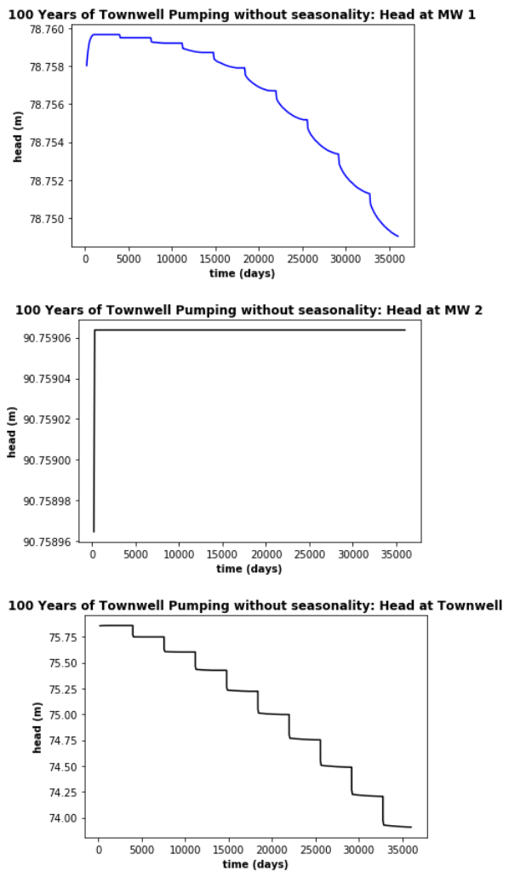

Final Head at Monitoring Well 1 = 78.507614 m

Final Head at Monitoring Well 2 = 87.80981 m

Final Head at Irrigation Well = 86.470856 m

Final Head at Aguaseca Community Well = 69.99967 m

Total Daily flux from river to groundwater (Oct-March SP) 13378.782236337662 m3/day

Total Daily flux from river to groundwater (Apr-Sept SP) 7395.87398147583 m3/day

Total = 20774.65

Without Seasonality:

Final Head at Monitoring Well 1 = 78.64693 m

Final Head at Monitoring Well 2 = 87.83266 m

Final Head at Irrigation Well = 86.49484 m

Final Head at Aguaseca Community Well = 70.06328 m

Total Daily flux from river to groundwater (Oct-March SP) 10085.025009155273 m3/day

Total Daily flux from river to groundwater (Apr-Sept SP) 10076.046303749084 m3/day

Total = 20161.06

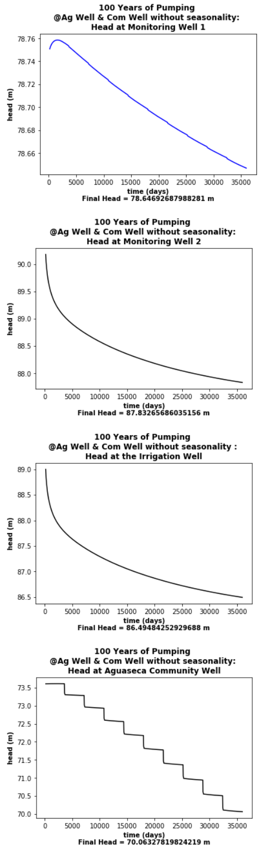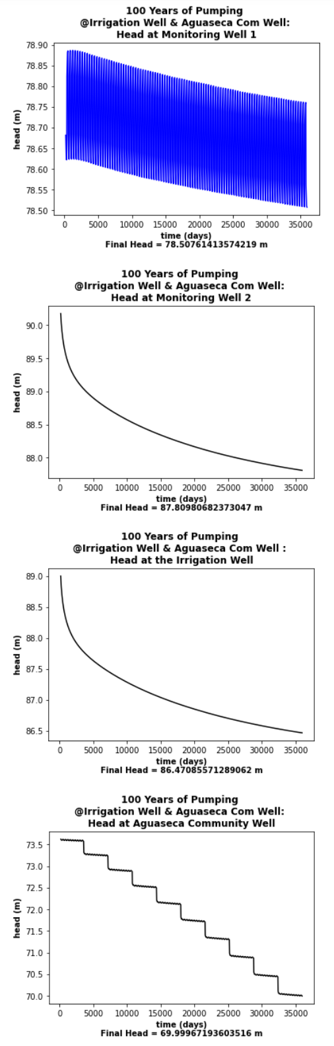

*Figure __*

*Figure __*